|  |  |  |  |
| --- | --- | --- | --- |
| Name:  Teacher : | ____________________________________  ______________________ | | Date:_________ |
|  | **Year 12 Essentials**  /39  **Linear Equations 1**  **Full working out MUST be shown to get full marks for each question.** | | |
| **Total Time:** | 45 minutes |  | |
| **Weighting:** | 5% |
| **Equipment:** | Pen, pencil, ruler, scientific calculator, 1- 2-sided page of notes | | |

1. Determine the value of the pronumeral in each of the following. [4 marks]

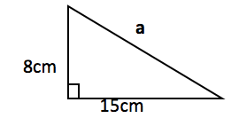

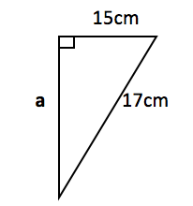

2. Laura is buying a television. It has a 34 inch screen. If it is 16 inches tall, how wide is the screen? Her television cabinet is 19 inches wide. Will the television fit in it? [3 marks]

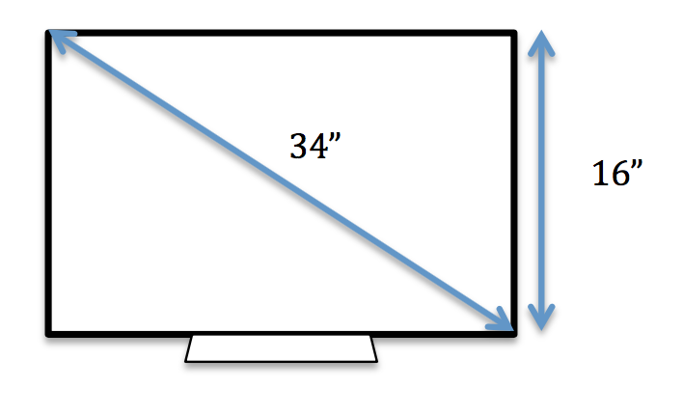

3. 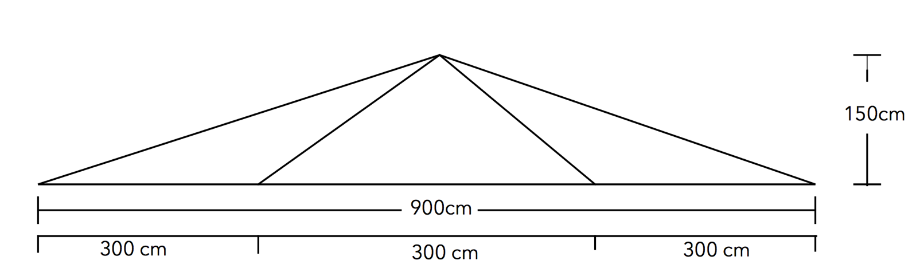Sam builds a roof support. It is 900cm wide, 150cm tall and is supported by 4 diagonal beams. The two outer beams are the same length, and the two inner beams are the same length. How much total wood would Sam need to build their structure? [6 Marks]

4. Find the ratio for sine, cosine and tangent using the triangle below, and theta as a reference. [3 marks]

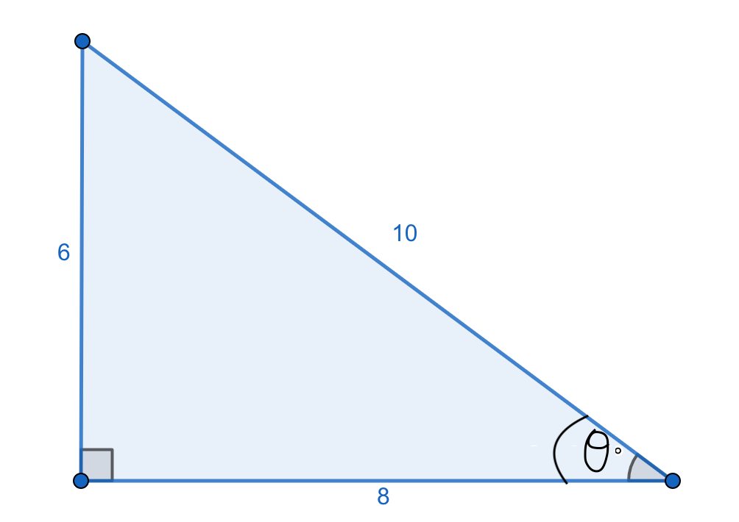

5.Determine the value of the pronumeral in each of the following [3+3 = 6 Marks]



b.



6. Find the value of the missing angle in the triangle below. [3 Marks]

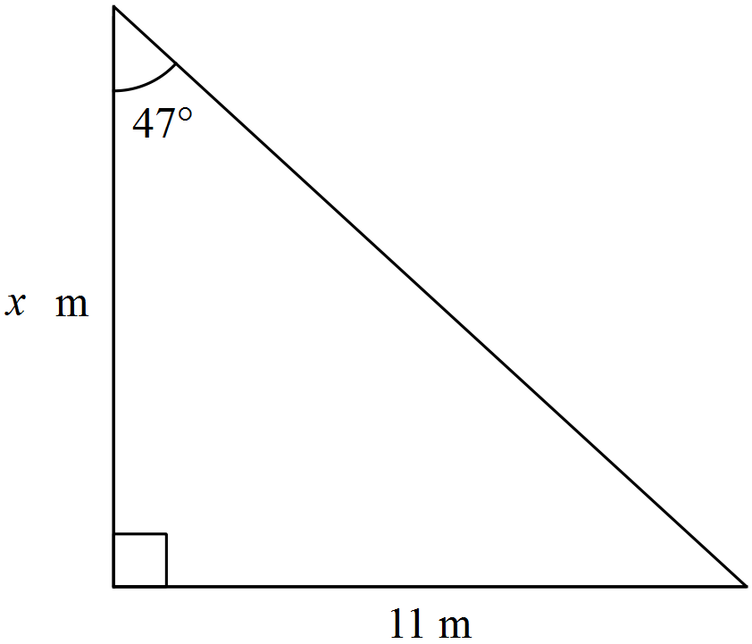

$$θ$$

$$θ$$

23m

23m

7. Sarah stands on top of a totem pole that is 30m tall. She sees another smaller pole in the distance that she knows is 5m tall. She works out that it is at an angle of depression of 15 degrees. How much rope would she need to make a zipline between the two poles? [4 marks]

8. A boat is seen from the top of a 25 m lighthouse, on a 315 m tall cliff. The boat is 600m away from the base of the cliff. Find the angle of depression to the boat in the ocean. [4 Marks]

9. From an observer at O who is 200m from the base of a building, the angles of elevation to the bottom and top of a flagpole are 36º and 38 º respectively. Find the height of the flagpole. [6 marks]

